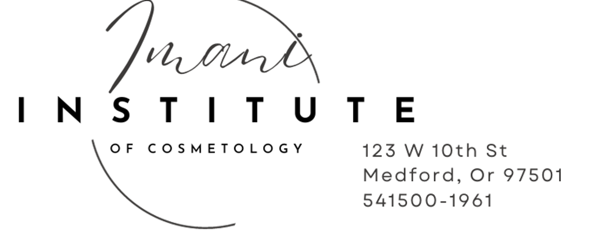
2025/2027 STUDENT ADMISSION & ENROLLMENT AGREEMENT
- Imani Institute of Cosmetology is a Clock Hour Cosmetology Program.
- The hours, schedule, and end date may vary depending on the program and student needs.
- Students must meet all school and state requirements to be eligible for graduation.
PLEASE PRINT CLEARLY AND MAKE SURE EVERY BOX IS CHECKED AND SIGNED
Name: | Social Security #:
Address:
City: | State: Zip
Cell #: | Date of Birth:
RACE: | Email:
Emergency Contact: | Phone:
ENROLLMENT DETAILS  ENROLLMENT DATE: ____________________________  START DATE: ___________________________  END DATE: ____________________________ | PROGRAM/S_________________________________
The above student is enrolling in a program licensed by the Oregon Higher Education Coordinating Commission designed to train and prepare for practice in the field of (Please Circle)

Programs Offered at Imani Institute of Cosmetology ✨
  - Hair Design
  - Nail Technology
  - Esthetics Advanced Esthetics with CIMA
  - Nail Technology with CIMA
  - Esthetics with CIMA
  - Full Cosmetology
  - Barbering
  - Private Classes
  - Practical Classes
  - Advanced Esthetics
  - Tattoo
  - PMU (Permanent Makeup)
  - State Practical Preparation
  - Massage Therapy
Accreditation:
Imani Institute of Cosmetology is a private career school licensed by the Oregon Higher Education Coordinating Commission (HECC). While we are not accredited, this decision aligns with our focus on providing high-quality, hands-on training and maintaining affordability and flexibility for our students.
Reasons for Not Pursuing Accreditation:
Focus on Practical Training:
Our programs are designed to emphasize practical, hands-on training in a professional spa environment, ensuring our students are fully prepared for state licensing exams and real-world careers in the beauty industry. Accreditation often requires additional theoretical coursework that may not align with our targeted, industry-focused curriculum.
Affordability for Students:
Accreditation can increase operational costs, which are typically passed on to students in the form of higher tuition fees. By not pursuing accreditation, we are able to keep our programs affordable while still offering top-tier training and advanced technology like HydraFacial and fibroblast skin tightening.
Flexibility in Curriculum Development:
As a private career school, we can quickly adapt our curriculum to reflect the latest industry trends and technologies without waiting for lengthy accreditation approvals. For example, we are the only school in Southern Oregon offering high-end HydraFacial technology and advanced aesthetics training.
No Impact on Licensing or Career Opportunities:
Our programs meet all state requirements and prepare students to sit for state board exams. Students graduate fully qualified to pursue careers in their chosen fields, and many of our alumni have gone on to successful careers in beauty and wellness.

Specialized Focus:
We specialize in cosmetology-related fields like Hair, Nails, Esthetics, Barbering, Advanced Aesthetics, and Tattoo Artistry. Accreditation often requires schools to offer broader programs, which may not align with our specialized focus.
Transferring Credits to Other Schools:
Credits earned at Imani Institute of Cosmetology are not guaranteed to be transferred to other institutions. Transferability is at the discretion of the receiving institution.
ENROLLMENT COSTS
A non-refundable deposit of $250.00 is required to confirm your enrollment. Additional Fees:
If the student has not satisfied the program quantitative and qualitative requirements by the end of the scheduled hours (max time frame for completion) then subsequent overtime contract will be created based upon the hours necessary to complete the program, with an end date at 100% scheduled attendance and at $20 per hour.
*FINANCING FEES are based on financial agreement.
*LATE FEES are based on financial agreement. $100.00 after the 5th of each month, after the 10th of each month a suspension
Until paid, this may cause overtime hours. After 30 days of nonpayment a termination of Contract. Balance must be paid within 10 days to avoid collections.

LEAVE OF ABSENCE
Leave of Absence must be approved and only a 2-week period, tuition must continue to be paid.
All addition classes are to be paid up front; they are not part of your deposit made.
Optional Classes for Esthetics
Micro Needle Course $300.00 (give 1 TX)
Derma plane Course with Kit $350.00 with No kit $200.00
HydraFacial Specialist $500.00 no Kit 10 treatments must be done
Classic Eyelash Course $700.00 with Kit and Cima No Kit or Cima $400.00
Classic / Volume Lashes and Brow Lamination Course / Lash lift and tint $1200.00 with Cima
Brow Lamination Course and Lash lift and Tint Course With kit $625.00 With Cima No Kit $300.00
Brazilian Wax (no kit) $300.00
Spray Tan with Kit $500.00 without kit is part of our training

Private Classes (Non-Students) must show proof of license or enrollment at current school
Micro Needle Course NON-Student $450.00 (give 1 TX)
Lash Extension Course with Kit $1100.00
Lash lift and Tint Course with kit $725.00
Derma plane Course with Kit $500.00
HydraFacial no kit with Certification and 2 Hands on treatments $500.00
Brazilian Wax (no kit) $300.00
Spray tan with Kit $600.00
PMU includes Brow/ Lips and Liner Certification $3500.00 with Kit total 50 hours
Referred Pathway Practical’s:
Esthetics $500.00
Nails $450.00
Hair $600.00
Barbering $500.00
Full Cosmo $1100.00

TUITION AND FEES
PROGRAM | TUITION | BOOKS, KIT & SUPPLIES | REG. FEE | TUITION DEPOSIT | TOTAL COST
Accelerated Nails full time  With Cima | 4550.00 | 1800.00 | 250. | 1800.00 | 6600.00  not at this time
Nail Technology | $4450.00 | $1300 | $250 | $1500.0 | $6000.00
Esthetics | $7250.00 | $1600.00 | $250 | 1600.00 | $9700.00
Accelerated Esthetics Full time with CIMA | $7250.00 | $2300.00 | $250. | $2300.00 | $9800.00
Hair | $10950.00 | $2,500 | $250 | $2500.00 | $13700.00
Full Cosmo | $21000.00 | $4,160 | $250 | $5,000 | $25410.00
Barbering | $9200.00 | $1650.00 | $250 | $1650.00 | $11100.00
Advanced Esthetics | $12950.00 | $1800.00 | $250 | $3000.00 | $15000.00
Accelerated Advanced Esthetics Full time with Cima | 13950..00 | $2400.00 | $250. | $5000.00 | $16600.0
Tattoo /  Perm Make up | 8200.00  2250.00 | $2650.00  $1000.00 | $250. | $3000.00  $3250.00 | 11000.00  3250.00
Massage Therapy | 9700.00 | $1000.00 | $250. | $2000.00 | 10950.00
Tuition payments can be made cash or check with no fee, Credit and debit card payments have a 3% fee due the first of each month.
Discounts
**Referral Discount** $400.00 off Tuition after they have completed 50% of the program must be approved at enrollment.
**VA Family Benefit** $500.00 off for students not personally eligible for VA benefits but have an immediate family member who served,
Discount on any program for past students 10%

PAYMENT SCHEDULE
We require a non-refundable $250 registration fee in tuition to hold a student’s place in the class. The amount is applied toward the total balance. If a student cancels, they must re-enroll and pay a new registration fee.

PAYMENT OPTIONS
Tuition Deposit & Registration Fee must be paid prior to starting school.
1. $250 Registration deposit due at contract signing and is applied to the balance, Pay in Full at Orientation – You can receive a 5% Discount if you pay your Tuition in full at Orientation if no other Discounts have been applied. (Cash or check only)
2. $250 Registration deposit due at contract signing. Financing is available on an individual basis. Please meet with a financial advisor to determine a specific plan.
3. $250 Registration deposit due at contract signing. Please see the attached sheet for student specific information. (Scholarships, grants, job council, etc.)

Amount paid for deposit ____________ Date____________

Accepted Benefits: We accept funding from the Veteran’s Administrations, Indian Tribes, Vocational Rehabilitation, Job Source, Youth Plus, and scholarships.

PAYMENT PLAN
Minimum monthly payment $___________ if payment is not the minimum amount you will be subject to a late fee $__________ initial here, monthly payments can be larger but never less than min monthly payment. Payments are due each month unless paid in full.
Deposit due at Orientation $____________
Initial here________

**Monthly Payments** We offer 0% interest monthly payment plans while you are enrolled. The Full program balance must be paid by the end of the course.
**NO FAFSA** We do not participate in the FAFSA program or offer federal financial aid, but our flexible payment options make education accessible.

School Official Initials ____
Payments are due by the 1st of each month and late fee after 5th, $100.00 after the 10th suspension until current with late fee paid, Shall the first fall on a Saturday or Sunday Payment should be made prior to assure no late fee

Imani Institute of Cosmetology

QuickBooks Payment Authorization Form
By completing and signing this form, you authorize Imani Institute of Cosmetology to set up and process your tuition payments through QuickBooks. Please review the payment processing fees below and provide your signature to grant permission.
Student Name: ___________________________________________
Email: _________________________________________________
Phone: _________________________________________________
Payment Method (select one):

☐ Credit Card (3% processing fee per transaction)

☐ Venmo (3% processing fee per transaction)

☐ Auto Transfer from Bank (1% processing fee per transaction)
Fee Disclosure:
Payments made by credit card or Venmo will incur a 3% processing fee per transaction.
Payments made by auto transfer from your bank will incur a 1% processing fee per transaction.
These fees will be added to your invoice or charged after your payment is processed.
Authorization Statement:

I authorize Imani Institute of Cosmetology to set up and process my tuition payments through QuickBooks, including the applicable processing fees as outlined above. I understand that I may revoke this authorization at any time by providing written notice.
Student Signature: ________________________________________
Date: ___________________________
Imani Institute of Cosmetology

QuickBooks Payment Authorization Form
By completing and signing this form, you authorize Imani Institute of Cosmetology to set up and process your tuition payments through QuickBooks. Please review the payment processing fees and late payment policy below, and provide your signature to grant permission.
Student Name: ___________________________________________
Email: _________________________________________________
Phone: _________________________________________________
Payment Method (select one):

☐ Credit Card (3% processing fee per transaction)

☐ Venmo (3% processing fee per transaction)

☐ Auto Transfer from Bank (1% processing fee per transaction)
Fee Disclosure:
Payments made by credit card or Venmo will incur a 3% processing fee per transaction.
Payments made by auto transfer from your bank will incur a 1% processing fee per transaction.
These fees will be added to your invoice or charged after your payment is processed.
Late Payment Policy:
Payments are due on the 1st of each month.
Payments received after the 5th of the month will incur a $100.00 late fee.
Payments not received by the 10th of the month will result in suspension from attendance until your account is current.
Authorization Statement:

I authorize Imani Institute of Cosmetology to set up and process my tuition payments through QuickBooks, including the applicable processing fees and late fees as outlined above. I understand that I may revoke this authorization at any time by providing written notice.
Student Signature: ________________________________________
Date: ___________________________

Important Payment Policy Update
Please review the following payment guidelines, effective immediately:
Payment Due Date: Payments are due on the 1st of each month.
Minimum Monthly Payment: $500.00. If you pay more in a given month and still have a balance, you are required to make at least a $500.00 payment the following month.
Payment Methods & Fees:
Credit Card or Venmo: 3% processing fee will be invoiced to you after payment.
Auto Transfer from Bank: 1% processing fee will be added after your payment is made.
In-Person Payments at School:
Cash or Check: No fee.
Credit Card: 3% processing fee applied at the time of payment.
Late Payment Fees:
Payments made after the 5th of the month will incur a $100.00 late fee.
Payments not received by the 10th of the month will result in suspension from attendance until your payment is made and your account is current. Please note: missing class due to late payment may lead to overtime charges.
Returned Payments:
Any returned payment (NSF) will incur a $25.00 fee.
If a payment must be reprocessed after the 5th, the late fee will also apply.
If you have any questions about your balance or payment options, please contact the office directly. Thank you for your attention to these policies and your commitment to staying current with your tuition.

I understand Balance to be paid at end of program prior to Final Practical

Initial here ______

REFUND AND CANCELLATION POLICY
- Full refund.
You may cancel enrollment by giving written notice to the school. If notice occurs:
- Within 5 business days of the date of enrollment, all monies paid shall be refunded.
- After 5 days of the date of enrollment and prior to classes, the school may retain only the published registration fee. Such a fee shall not exceed 15% of the total tuition cost, or $250, whichever is less.
- Pro Rata Tuition.
If the student or school terminates training after classes begin, the student is financially obligated to the school according to the following formulas or maximum charges:
  - If a student withdraws prior to completion of 50% of the contracted scheduled hours of the instructional program, the student shall be entitled to a pro rata refund of the tuition charged for scheduled hours, and paid for such an instructional program, less registration fees, supply fees, and any other charges owed by the student; Book, kit and supply fees are non-refundable after the first-class day.
  - If a student withdraws upon completion of 50% or more of the contracted instructional program, the student shall be obligated for the tuition and fees charged for the entire instructional program and shall not be entitled to any refund.
  - Pro rata refund means a refund of tuition paid for that portion of the program not received by the student. The date for determining that portion shall be the published course schedule and the last recorded date of attendance by the student.
  - Imani Institute of Cosmetology follows the required hours set by the state for each individual program.
  - If a student withdrawal and has a balance owing to the balance musty ne paid immediately, accounts are turned over to collections after 10 days from the date of withdrawal.
Imani Institute of Cosmetology reserves the right to expel any student for inappropriate behavior, property damage, or theft. The above refund policy will be implemented at the appropriate Pro Rata Tuition for the last recorded date of attendance

➢ Refund Policy for VA Students Only: XX’s Veterans Refund Policy complies with CFR 21.4255. In the event the veteran or eligible person fails to enter the course, withdraws, or is dismissed at any time prior to completion, any unused portion of tuition, fees, and other charges are refunded. Any amount in excess of $10 of the registration fee is subject to pro-ration. The amount charged will not exceed the exact pro rata portion of total charges. The length of the completed portion of the course will be prorated over its total length, and the exact pro-ration will be determined by the ratio of the number of days of instruction completed by the student, to the total number of instructional days in the course. Refunds are made when a balance due is issued from the VA on the days of the last date of student’s attendance.

TIME FRAME FOR COMPLETION
The time frame for completing a program staying at a Part Time 23 hour/week schedule is listed below for each program.
Program | Program Hours | Minimum Contracted weeks | Months
Nail Technology | 281 | 15 | 4
Esthetics | 484 | 23 | 6
Hair Design | 1150 | 52 | 13
Full Cosmo | 1835 | 86 | 22
Nails and Esthetics | 725 | 38 | 10
Hair and Esthetics | 1594 | 75 | 19
Barbering | 786 | 41 | 11
Advanced Esthetics | 500 | 22 | 6
Tattoo | 360 | 15 | 4
Tattoo Make up | 50 | 2
Massage Therapy | 625 | 33 | 8

The time frame for completion of a program switching to a Full Time 38 hour/week schedule after back class is listed below for each program.
Program | Program Hours | Minimum Contracted weeks | Months (Weeks/4.1weeks per month)
Nail Technology | 281 | 10 | 2.5
Accelerated Nail Technology | 281 | 10 | 2.5
Esthetics | 484 | 15 | 4
Accelerated Esthetics | 484 | 12 | 3
Hair Design | 1150 | 32 | 8
Full Cosmo | 1835 | 53 | 13.25
Nails and Esthetics | 765 | 24 | 6
Hair and Esthetics | 1634 | 46 | 11.5
Barbering | 786 | 26 | 6.5
Advanced Esthetics | 500 | 22 | 4.5
Accelerated Advanced Esthetics | 500 | 15 | 3.5

SATISFACTORY PROGRESS & ATTENDANCE, TARDINESS AND CLASS CUT POLICY STANDARDS

Normal Time for Completion is determined by Contracted Scheduled Hours. Students must maintain 87% attendance to maintain satisfactory academic progress. Students should be aware that contracted end dates do not change if classes/exams are failed or missed due to hours/days missed. The grace period is built into the student’s maximum time frame for completion to cover Doctor’s appointments, illness, personal days, and/or any other events in the student’s life that may cause minor absences. If absences exceed the max time frame for scheduled hours of completion, then the student will be billed for overage charges at a rate of $20.00 per hour, during back class (Theory) if you miss more than the allowed days, you will have to repeat the class at the next enrollment date. It is important you do not miss school as it can affect your fellow students and Instructors,

MAX TIME FRAME FOR COMPLETION End Date: _________________

Total Missed days allowed: _______________ Signed: _______________________ Date: _________

STUDENT SCHEDULES

Full Time 38-hour/week
(Monday-Friday 8:45am to 5:00pm, additional hours available
Part Time 23-hour/week

Student Schedule Policy

All students are required to adhere strictly to their assigned schedules. This includes:
Arriving on time for the start of each class or practical session.
Remaining for the full duration of the scheduled hours.
Not leaving early or arriving late unless prior approval has been granted by the administration.
Why This is Important:
Consistent attendance ensures students meet the required hours for program completion.
It supports a professional learning environment and prepares students for workplace expectations.
Missed or incomplete hours may result in additional charges or delays in program completion.
Note: Failure to follow the schedule may result in disciplinary actions, including suspension or additional fees for overtime hours required to make up missed time.

Students enrolled in High school programs may extend the timeframe for graduation based on school hours and academic schedule.

OVERTIME CONTRACT CHARGES
If the student has not satisfied the program quantitative and qualitative requirements by the end of the scheduled hours (max time frame for completion) then subsequent overtime contract will be created based upon the hours necessary to complete the program, with an end date at 100% scheduled attendance and at $20 per hour.

You are required to make up every hour missed, including tardies and absences. The cost is
$20 per hour over the contracted scheduled program hours.
You will be allowed the following excused absences (grace period) with no overtime contract charges (hours must be made up):

Full Cosmo (20 days/160 hours excused absences)
Nails (4 days/32 hours excused absences)
Esthetics (5 days/ 40 hours excused absences)
Hair Design (11 days/88 hours excused absences)
Barbering (7 days/49 hours excused absences)
Advanced Esthetics (5 days/ 40 hours excused absences)
Tattoo (4 days/32 hours excused absences)
Permanent Makeup Tattoo (0 days)
Massage Therapy (5 days/ 40 hours excused absences)

GRADUATION/COMPLETION REQUIREMENTS
On-Floor Client Service Expectations
Daily Client Services Requirement:
Students are required to perform a minimum of 2 client services per day while on the floor.
Advertising and Promotion:
Advertising and promoting your services are an essential part of your business plan.
Students must complete a minimum of 3 advertisements weekly to attract clients.
Responsibility for Clients:
Imani Institute of Cosmetology is not responsible for providing clients. Students are expected to take an active role in building their client base.
Completion of Signoffs: sign offs will not be signed if you do not follow guidelines of services, along with sanitation procedures.
Completing your signoffs does not mean you are finished taking clients.
Every opportunity to take clients while in school is a chance to learn, grow, and refine your skills.
Client Refusal Policy:
No client will be turned away. Refusing to take a client may result in disciplinary action, including suspension.
Use of Time:
Students are expected to use their time productively. This is not a time to sit on your phone or socialize with friends. If you are in multiple programs, you are required to take clients for all programs you are enrolled in.
Note: Taking advantage of every client interaction will enhance your practical experience and prepare you for success in the industry.

Signature: ______________________

Practical Dates
Third week of the Month
Written: Mondays from 9am to 11am
Practical’s: Hair/ Barbering Wednesday 9am to 5pm, Nails/Esthetics Thursday 9am to 5pm
If you miss the practical date, you must schedule for the following month. The practical’s are your state hands on test and should be treated like it, no students give practical’s to other students, the rooms are to be only you, the client and the instructor, no guest, no talking, and no food or drinks permitted in the room.

Students must pass and complete all practical exams. Homework and theory exams must be passed with a 75% or better. Students must also complete the minimum required number of services (specific to each program). All tuition and overtime charges must be paid in full by graduation/end of attendance period for your program of study.
Students will not be eligible to complete state practical and final testing until all tuition and overtime charges are paid in full. Once all requirements are met and your balance is cleared, a Certificate of Completion will be issued, and your official transcripts will be sent to the Oregon Higher Education Coordinating Commission so you may register for the State Board Exam.
If your practical exam score is below 75%, the exam must be retaken by appointment only at a rate of $250.00.

PLACEMENT ASSISTANCE:
The school does not guarantee employment or placement assistance; we do post flyers from local businesses looking for graduates of Imani.
ACKNOWLEDGEMENT:
This contract constitutes a binding contract between the student and the school when signed by all applicable parties and upon acceptance by the school. By signing below, you certify that you have read all pages. You will receive an exact copy of the signed contract. Keep it to protect your rights. The school reserves the right to change the program start dates based on class enrollment, staff availability and other considerations. If the school changes the start date for the new student, the student must re-sign a new enrollment agreement with the new start date on the current enrollment agreement. I agree to receive information via texting and email from Imani Institute of Cosmetology. I agree with photos taken and posted for advertisement

I agree to give consent for Photos and post on social media to be used for Imani Institutes Advertisements: _______________

If you choose a part time schedule it will stay as the program you have enrolled for / if multiple programs you may choose the days 9-5 / Full time would be Monday thru Friday_______________ Only the Director can change your schedule.

I have read and received a copy of this agreement and the student completion and placement data [as required in 715-045-0018 (1) (a-d)] I also have read and received the school catalogue. My signature indicates I understand the agreement, the program’s requirements and agree to any stipulations listed in them.

Student’s Printed Name: _____________________________
Student’s Signature: _________________________________ Date: ___________

This Enrollment Agreement is with you and you alone, meetings with students are not with parents or friends, no information will be shared unless you are a minor than all information will be shared upon the signed guardians request.

Signature: _________________________________ Date: ____________________

Guardian understands this is a binding contract and you are responsible for your minor child:

Guardian/Sponsor Printed Name: ___________________________________
Address: ________________________________________________________
City: _____________________ State: ___________ Zip: __________
Phone: ___________________________
Guardian/Sponsor Signature: (if applicable) __________________________

School Official: _______________________________ Date: __________

Any inquiry a student may have regarding this contract may be made in writing:
Imani Institute of Cosmetology
123 W 10th St.
Medford, Or 97501,
Or
Higher Education Coordinating Commission
3225 25th Street SE,
Salem, Oregon 9730

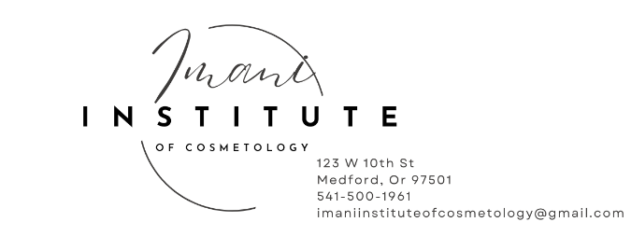
Program Start Dates for 2025

Nail Technology Dates for 2025
- July 7th, 2025
- August 11th, 2025
- September 22nd, 2025
- November 3rd, 2025
- December 15th, 2025
Nail Technology Start Dates for 2026
- February 9th, 2026
- March 30th, 2026
- May 11th, 2026
- June 22nd, 2026
- August 3rd, 2026
- September 14th, 2026
- October 26th, 2026
- December 1st, 2026
Hair Design & Barbering Start Dates for 2025
- July 7th,2025
- September 15th, 2025
- November 24th, 2025
Hair Design & Barbering Start Dates for 2026
- February 2nd, 2026
- April 13th, 2026
- June 22nd, 2026
- August 31st, 2026
- November 9th, 2026

Advanced Esthetics Start Dates for 2025
- August 11th. 2025
- October 20th, 2025
Advanced Esthetics Start Dates for 2026
- February 9th, 2026
- June 1, 2026
- October 2026
Esthetics Start Dates for 2025
- July 2nd, 2025
- August 27th, 2025
- October 22nd, 2025
Esthetics Start Dates for 2026
- January 7th, 2026
- March 4th, 2026
- April 29th, 2026
- June 24th, 2026
- August 19th, 2026
- October 14th, 2026
- December 9th, 2026
Tattoo Artistry Program Start Dates 2025
- July 7, 2025
- September 15, 2025
- December 8, 2025
Tattoo Artistry Program Start Dates 2026
- March 2, 2026
- May 25, 2026
- August 17, 2026
- November 9, 2026
Massage Therapy Massage Program Dates 2025
- September 8th, 2026
- November 24th, 2026
Massage Therapy Massage Program Dates 2026
- February 23rd, 2026
- May 18th, 2026
- August 3rd, 2026
- October 19th, 2026

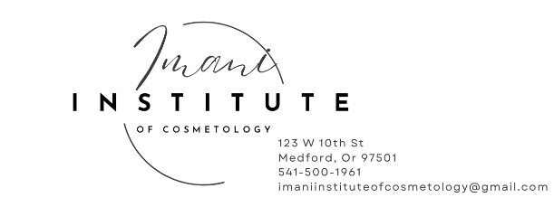
Imani Institute of Cosmetology
Individual Student Financing Plan
Total Cost of Attendance for Program $_______________
Tuition and fees $_______________
Books and supplies $_______________
Registration $_______________
Transportation $_______________
Other education costs (Private Classes) $_______________
Estimated Cost of Attendance $_______________

Family contribution $_______________

Imani Referral Discounts $_______________
after the reefing student has passed 50% of enrollment

Family Veteran discount $_______________
Imani Institute Discount $_______________

Scholarship and Grant Options
Scholarships and Grants are considered "Gift" aid - no repayment is needed.
Scholarships

Merit-Based Scholarships
Scholarships from your school total $_______________
Scholarships from your state $_______________
Other scholarships $_______________
Employer Paid Tuition Benefits $_______________
Total Scholarships $_______________

Work study
Days worked x hours at $15.00 per hour
Deducted off tuition ________________________________
$_______________
VA Education Benefits $_______________
VA Education Benefits $ $_______________

College Costs You Will Be Required to Pay $_______________
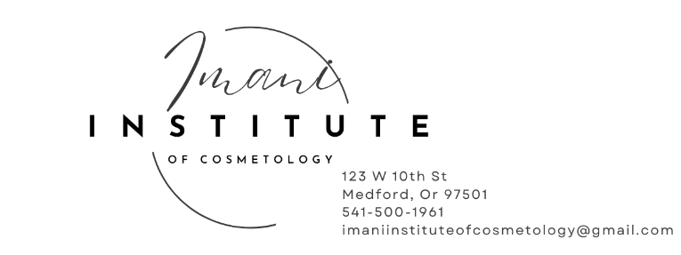

Proof of Enrollment 2025
STUDENT ADMISSION & ENROLLMENT AGREEMENT

- Imani Institute of Cosmetology is a Clock Hour Cosmetology Program.

Name:
Address:
City: | State: Zip:
Cell #:
Birth Date: | Email:

Hair Design
Nail Technology
Esthetics
Full Cosmo
Barbering
Advanced Esthetics
Tattoo
Massage Therapy

ENROLLMENT DATE: _____ _______________________________

START DATES: END DATES: __________

Student’s Signature: _____________________________ Date: _________

Student’s Printed Name: ________________________________

School Official: ________________________________ Date: _________

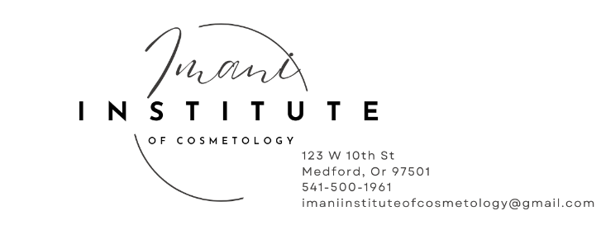

Beauty supply stores:

Cosmo Prof
1390 Biddle Rd #102,
Medford, OR 97504

Salon Centric - Medford
1112 Progress Drive,
Medford, OR 97504

Scrub Hub
Uniform store in Medford, Oregon
20 S Fir St,
Medford, OR 97501
Phone: (541) 500-1506
10% discount on Black scrubs to students

Sun Palace
Established destination providing tanning services and a variety of nail care options.
1112 Progress Dr # 113,
Medford, OR 97504
Phone: (541) 772-6350

